**EE101 Homework 4**

**Submit: Blackboard Due: Nov. 28th**

**Your Name: ______________ Student ID: __________________**

1. Calculate the distance at which the intensity of a 1 MHz and 8 MHz ultrasound beam will be reduced by half traveling through (a) bone, (b) air, and (c) muscle.

(The attenuation coefficient for muscle, bone and air are 1, 8.7 and 45 dB cm-1 MHz-1, respectively. $dB =10\log_{10}{(\frac{I_{x}}{I_{0}}})$)

1. The three ultrasound images in Figure 2 are acquired from the same object.

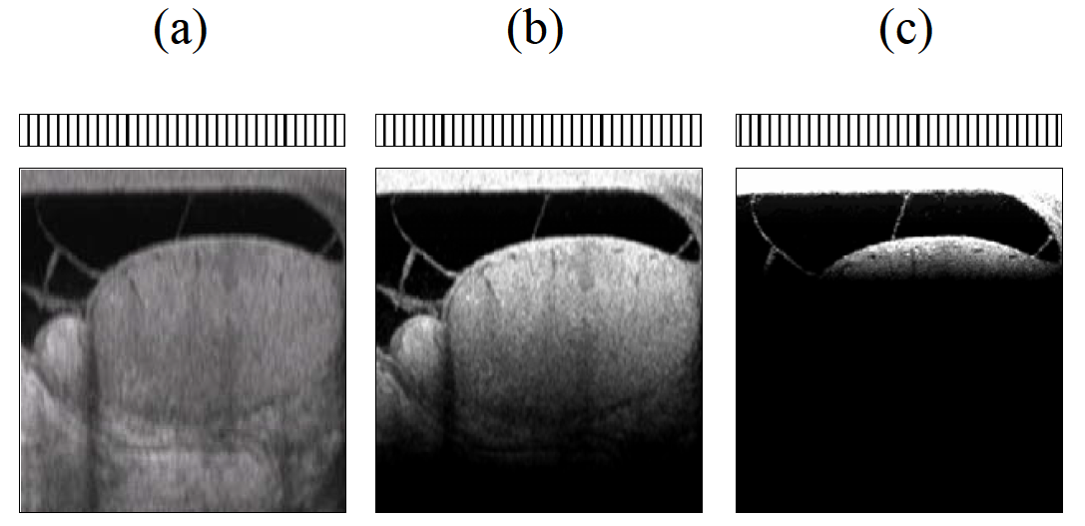

*Figure 2*

Answer the following questions:

1. Please analyze the difference among the three images referring to image characteristics, for example image depth, SNR, etc.
2. If only a single operating parameter changes and causes the difference among image (a), (b) and (c), which parameter could it be? Explain why.
3. Given the transmitted frequency spectrum of an ultrasound beam from a transducer operating at a central frequency of 1.5 MHz and assume that the transducer is damped.
4. Please plot the beam returning to the transducer after having passed through tissue and been reflected.
5. Explain the reason why your draw the reflected spectrum like this.

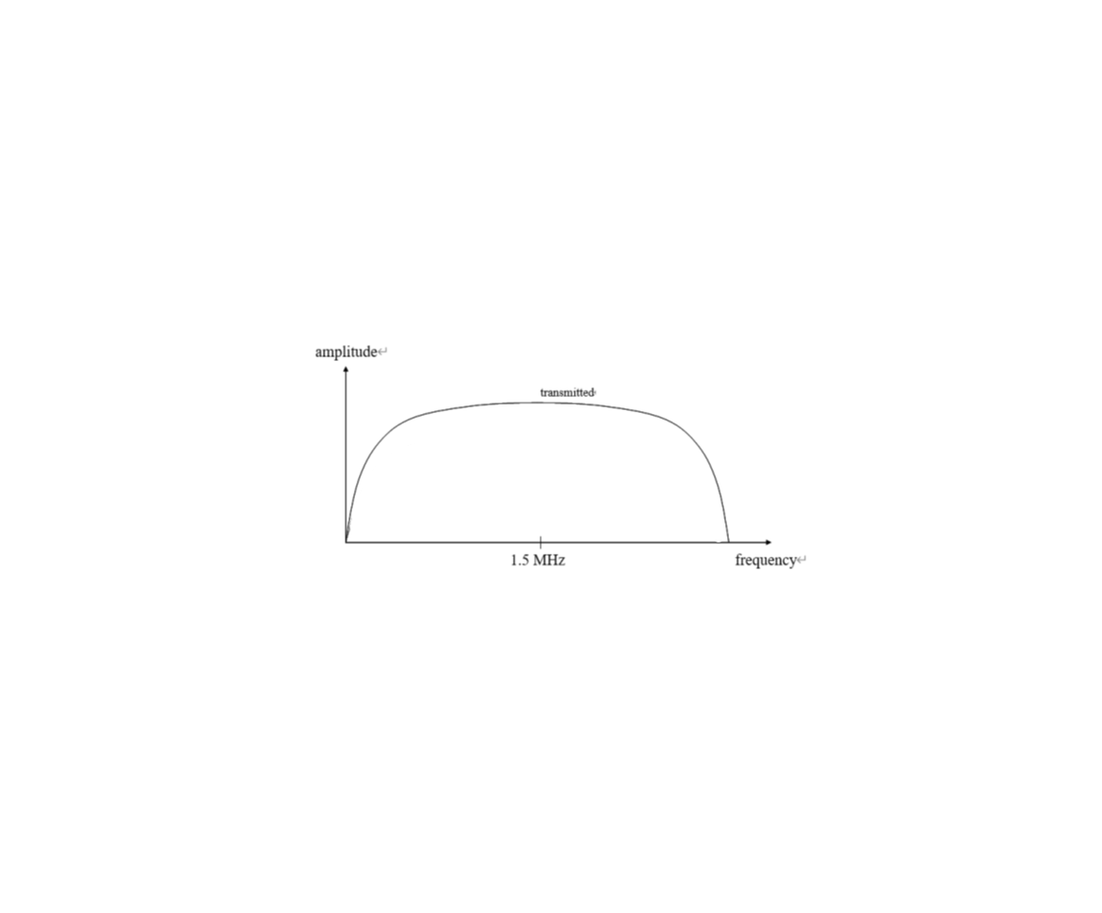

*Fig3: The transmitted frequency spectrum with central frequency of 1.5MHz*

4. If we only consider the transmission process of ultrasound wave and neglect the multiple reflection in different boundaries, please answer the following questions:

(1) Given values of $ZPZT$ and $Zskin$ of $25×{10}^{5} g cm^{-2}s^{-1}$ and $2.7×{10}^{5} g cm^{-2}s^{-1}$, respectively, calculate what fraction of the energy from the transducer is actually transmitted into the patient if one matching layer is used.

(2) If two matching layers are used instead of one, and the respective acoustic impedances are given by the analogues of the equation above, then calculate the increase in efficiency in transmitting power into the patient.

5. A B-mode scan is taken of the object in Figure 5.a with a linear array. There are four tissue components, ***a*** and ***b*** with a boundary in-between and two spherical tumors ***c*** and ***d***. Given the corresponding ultrasound image shown on Figure 5.b, which is the enlargement of the blue region in Figure 5.a. What can you deduce about the acoustic characteristics of components ***a***, ***b***, ***c*** and ***d***?

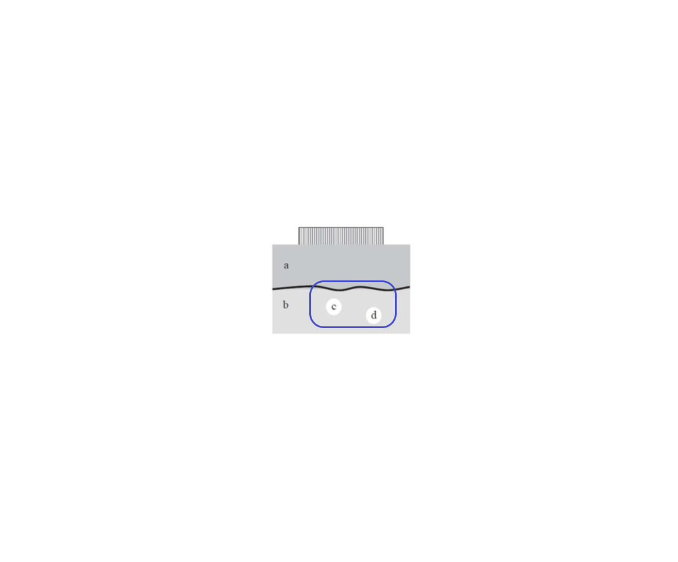

*Figure 5.a*



*Figure 5.b*

1. Sketch the Doppler spectral patterns at points 1, 2, and 3 below in a stenotic artery, shown in Figure 6.(All of the plots are made over one cardiac cycle)

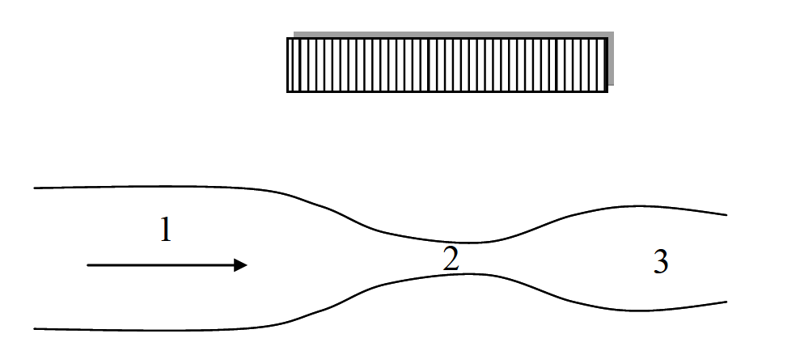

*Figure 6*